Role of hydraulic conductivity on the mechanism of earthquake induced submarine landslides – a CFD-MPM analysis

Q.A. Tran1, E.R. Sørlie1, G. Grimstad1, G.R. Eiksund1

*1Department of Civil and Environmental Engineering, Norwegian University of Science and Technology, Norway*

**ABSTRACT:**

Submarine landslides can occur in soil types such as clay and sand. The failure mechanism and morphology of these two types of submarine landslides are quite different. Sand failures are typically characterized by sand flow slides, whereas clay failures are characterized by spread, which result from the dislocation and movement of soil blocks. There are significant differences between these types of submarine landslides due to the differences in hydraulic conductivity. It is hypothesized that that the hydraulic conductivity of soil and rock layers is a critical factor in the failure mechanism of seismic-induced submarine landslides. It is, however, unclear how the hydraulic conductivity influences the failure mechanism of seismic induced submarine landslides. Utilizing an advanced numerical technique (coupled Computational Fluid Dynamics and Material Point Method), we simulate the full process of seismic-induced submarine landslides and examine the role of the hydraulic conductivity of the soil in their failure mechanism.

**Keywords:** submarine landslides, Computational Fluid Dynamics, Material Point Method.

# INTRODUCTION

Submarine landslides are a major concern in areas of high seismic activity, as they can cause significant damage to coastal infrastructure and lead to tsunamis. Simulating the full process of a submarine landslide is difficult. This is because sediments behave as solid materials when the slide is triggered and as fluid materials after the slide has failed. In recent studies, particle-based methods have been utilized to simulate submarine landslides, including the Material Point Method (MPM) (Shi et al., 2020), Smooth Particle Hydro Dynamics (Capone et al., 2010), Particle Finite Element Method (Zhang et al., 2019), or Coupled Eulerian Lagrangian method (Dey et al., 2016). Yet, they used only total stress analysis in classical soil mechanics. As a result, we have yet to be able to quantify the role of hydraulic conductivity in the mechanism of earthquake-induced submarine landslides, even though it is a key factor that influences the failure mechanism of submarine landslides because it governs the change in pore water pressure in the sediment.

To investigate the role of hydraulic conductivity in the failure mechanism of seismic-induced submarine landslides, we adopt the current state-of-the-art numerical technique coupled CFD-MPM model. In a coupled CFD-MPM method, MPM is used to deal with large deformations in solids or porous media, while CFD is used to analyze fluid dynamics. The MPM model is used for modeling the seabed and debris flows, while the CFD model is used for modeling fluid dynamics (water and air). This method preserves the advantages of both CFD and MPM by combining them together. MPM is able to define more sophisticated solid/soil constitutive models, which are essential for the initiation mechanism of the flow. Through contact laws, such as Coulomb's friction, solids (MPM materials) interact. In a contrast, CFD is the most commonly used method for simulating complex viscous fluid flows involving turbulence (uniform fluctuations in flow) or hydroplaning (debris flows losing friction with the seabed). Overall, CFD-MPM simulations of debris flow underwater are able to capture complex mechanisms involving solid-fluid interactions.

# problem definition

We consider a base case in this study shown in Figure 1. A 20-meter slope with a 45-degree gradient is placed within a horizontal and vertical structure. This structure was used as a shaking table to apply earthquake loading. To simplify earthquake loading, we simulated ground shaking for 20 seconds at a peak ground acceleration of 1g and a frequency of 2Hz (Figure 2). Ground motion is expressed in terms of velocity. A magnitude 6 or greater earthquake can produce a similar frequency and peak ground acceleration.

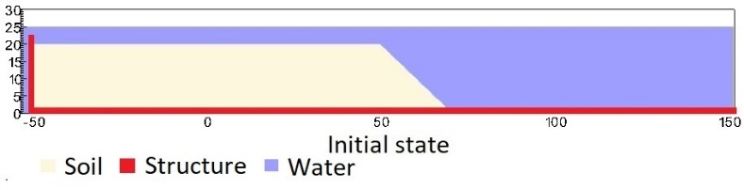

Figure 1. Geometry of the base case slope

Figure 2. Ground acceleration profile, frequency of 2Hz and magnitude of 1g

In order to highlight the role of hydraulic conductivity on the failure mechanism of earthquake-induced submarine landslides, two simulations are analyzed, including (1) the low hydraulic conductivity case and (2) the high hydraulic conductivity case. The hydraulic conductivity is calculated based on the size of the soil grain, the viscosity of the fluid, and the soil volume fraction.

# COUPLED CFD-MPM ANALYSIS

## Soil-Water-Structure interaction

Figure 2. Schematic of soil-water-structure interaction

We implemented the coupled CFD-MPM model in the Uintah computational framework (Tran et al., 2022) to capture the triple interaction between soil-water-structure following the . The CFD approach is derived from the implicit continuous-fluid Eulerian method (ICE). In ICE, all state variables are located at the cell/body centers. The state variables at cell centers are given in the vector form of the material *r $\left(M_{r}, u_{r}, e_{r},T_{r},p,{}_{r},{}_{r}\right)$* including mass, velocity, internal energy, temperature, pressure, volume fraction and specific volume. The MPM approach adopted the generalized interpolation technique from Bardenhagen and Kober (Bardenhagen & Kober, 2004). This method was validated with laboratory experiments (Tran et al., 2017a; Tran et al., 2017b) and large-scale landslide (Tran & Sołowski, 2019). To couple MPM with ICE, the state variables of MPM material points including mass, velocity, temperature and effective stress $\left(M_{p}, u_{p}, T_{p},{}^{'}\right)$ are mapped to cell centers using generalized interpolation technique. Then, the following governing equations are solved at the Eulerian background mesh:

*Mass Balance Equation*

|  |  |  |
| --- | --- | --- |
|  | $$\frac{1}{V}\frac{D_{r}M_{r}}{Dt}=0$$ | (1) |

*Momentum Balance Equation for fluid*

|  |  |  |
| --- | --- | --- |
|  | $$\frac{1}{V}\frac{D_{f}\left(M_{f}u_{f}\right)}{Dt}=-{}_{f}p+.{}_{f}+{\overline{}}_{f}g+\sum{f_{d}}$$ | (2) |

*Momentum Balance Equation for fluid*

|  |  |  |
| --- | --- | --- |
|  | $$\frac{1}{V}\frac{D_{s}\left(M_{s}u_{s}\right)}{Dt}=.{}^{'}-{}_{s}p+{\overline{}}_{s}g+\sum{f_{d}}$$ | (2) |

The last term is the momentum exchange between materials with dragging force $f_{d}$ with $K_{fs}$ is the momentum exchange coefficient. Apart from mass and momentum balance equations, we also solve the energy balance equations but not presented here in. This is also combined with the generalized Poisson’s equation to compute the fluid pressure for compressible fluid materials.

## Momentum Exchange

For the momentum exchange between fluid flows and porous media, we assume that the drag force $f_{d}$ is given by:

|  |  |  |
| --- | --- | --- |
|  | $$f_{d}=\frac{18{}_{s}\left(1-{}_{s}\right){}_{f}}{D_{p}^{2}}F({}_{s},Re)(u_{s}-u_{f})$$ | (2) |

where $D_{p}$ is the average grain size of the grains, the solid volume fraction is ${}_{s}$, the fluid viscosity is ${}_{f}$, Re is the Reynolds number and the relative velocities of soil grains and fluid is $(u_{s}-u_{f})$. The function $F\left({}_{s},Re\right)$ is given from CFD-MPM framework (Tran et al., 2022). In case the Kozeny Carman formula is used. The hydraulic conductivity can be express as:

|  |  |  |
| --- | --- | --- |
|  | $$K=\frac{1D_{p}^{2}{\left(1-{}_{s}\right)}^{3}}{180{}_{f}{}_{s}^{2}}$$ | (2) |

Here the hydraulic conductivity can be controlled by adjusting the grain sizes. Two grain sizes are selected for the numerical analysis (1) $D_{p}$ = 0.5 mm and (2) = 1e-4 mm to mimic the hydraulic conductivity of sand and clay.

## Soil and Fluid Models

A non-associated Mohr-Coulomb model is used for the soil. Young's modulus of 10 kPa and Poisson's ratio of 0.3 and zero cohesion. The mobilized friction angle ${}_{m}^{ '}$ is governed following the softening curve (Figure 1) with the peak friction angle ${}_{p}^{ '}$ of 45 degrees and the residual friction angle ${}_{r}^{ '}$ of 10 degrees. The mobilized dilatancy angle is calculated from the Row-stress dilatancy as follow:

|  |  |  |
| --- | --- | --- |
|  |  | (2) |

Figure 1. Mobilized friction angle in Mohr Coulomb model

The contact between horizontal plane and the soil is the frictional contact with the friction coefficient of 0.1. No artificial damping is applied in the simulation. The contact between vertical plane and the sand is considered to be smooth with zero friction coefficient. Under gravity, the density of the water at the surface is 999.8 kg/m3 at the pressure of 1 atm. At the top boundary, the air has a density of 1.17 kg/m3 at the atmospheric pressure of 1 atm. At 5 Celsius degrees, air and water have viscosity of 18.45e-3 mPa s and 1 mPa s respectively. On all boundary faces, the symmetric boundary condition is imposed, while the Neuman boundary condition is imposed at the top boundary for pressure (dp/dx = 0 kPa) and density (d/dx = 0 kg/m3). The mesh size is 0.25 x 025m with 300852 element cells and 142316 material points.

# Numerical Results

We compare simunlations with the same input parameters execpt for the grain size Dp. For the high hydraulic conductivity cases, the grain size is 0.5mm ($D_{p}$ = 0.5 mm) while for the low hydraulic conductivity cases, the grain size is 1e-4 mm ( = 1e-4 mm). We demonstrate the entire process and the mechanism of the earthquake induced submarine landslides for both cases and highlight the differences in the mechanism in each cases.

## High permeability case

For the high permeability case, the slope collapes right after the initial of the seismic event, the failure mechanism is charaterized as sand flow slide according to the updated Varnes classification (Hungr et al., 2014). The slope inclination after the landslides is less than 10 degrees (around 8 degrees) which is equivalent to the residual friction angle of the soil. The final shear band keeps developing event after the end of the shaking. The final shear band inclination is around 20 degrees.

**Fig. 5** Seabed near the Storegga slide area5

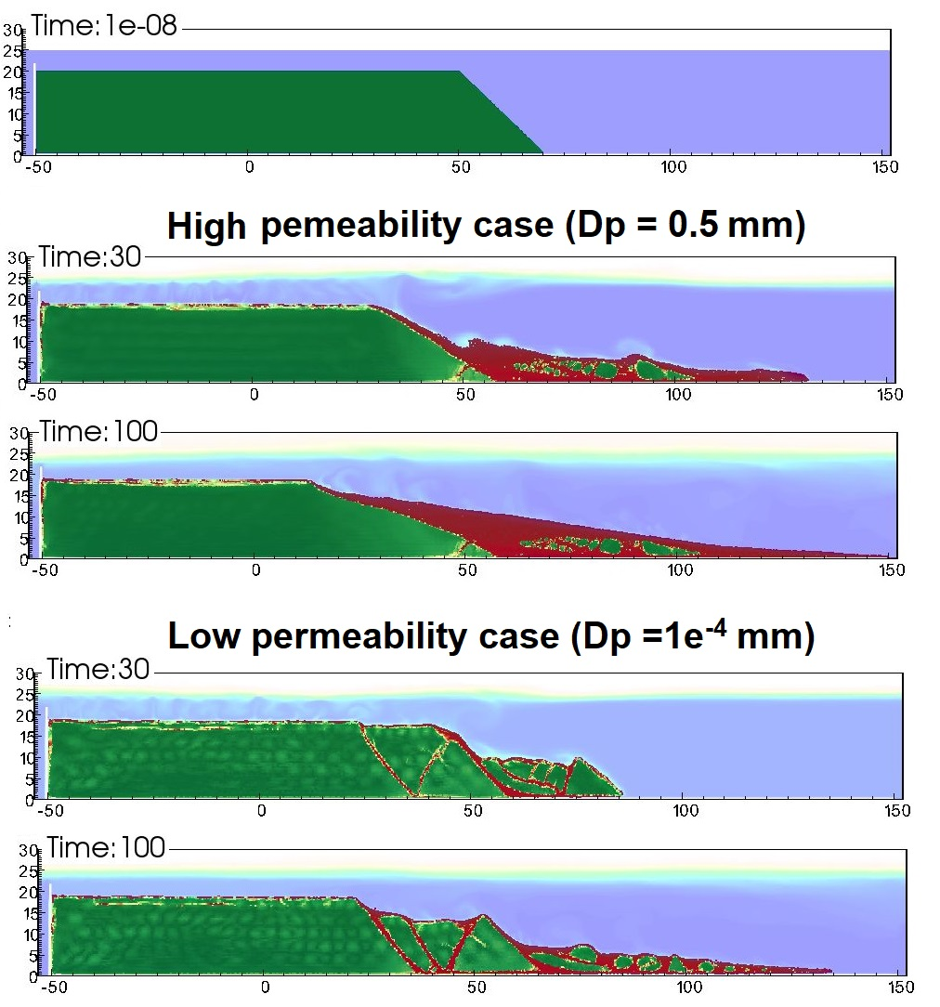

*Figure 1. Shear strain development for high permeability and low permeability cases*

# ConCLUSIONS

The findings of this research can be used to improve our understanding of the failure mechanisms of submarine landslides and to develop better methods for predicting and mitigating the potential damage caused by these events. Further research is needed to better understand the complex relationship between hydraulic conductivity, soil and rock properties and the failure mechanisms of submarine landslides, in order to improve the prediction of landslide susceptibility and improve coastal zone management.

# ACKNOWLEDGEMENTS

This project has received funding from the European Union’s Horizon 2020 research and innovation program under the Marie Skłodowska-Curie Actions (MSCA) Individual Fellowship (Project SUBSLIDE “Submarine landslides and their impacts on offshore infrastructures”) grant agreement 101022007. The computations were performed on High Performance Computing resources provided by UNINETT Sigma2 - the National Infrastructure for High Performance Computing and Data Storage in Norway.

# References

Bardenhagen, S. G., & Kober, E. M. (2004). The Generalized Interpolation Material Point Method. *Computer Modeling in Engineering & Sciences*, *5*(6), 477-496.

Capone, T., Panizzo, A., & Monaghan, J. (2010). SPH modelling of water waves generated by submarine landslides. *Journal ofHydraulic Research*, *48*(1), 80-84.

Dey, R., Hawlader, C., Phillips, R., & Soga, K. (2016). Numerical modelling of submarine landslides with sensitive clay layers. *Géotechnique*, *66*(6), 454-468.

Hungr, O., Leroueil, S., & Picarelli, L. (2014). The Varnes classification of landslide types, an update. *Landslides*, *11*(2), 167-194. <https://doi.org/10.1007/s10346-013-0436-y>

Shi, J. J., Zhang, W., Wang, B., Li, C. Y., & Pan, B. (2020). Simulation of a Submarine Landslide Using the Coupled Material Point Method. *Mathematical Problems in Engineering*, *2020*. <https://doi.org/Artn> 4392581

10.1155/2020/4392581

Tran, Q. A., Grimstad, G., & Ghoreishian Amiri, S. A. (2022). MPMICE: A hybrid MPM-CFD model for simulating coupled problems in porous media. Application to earthquake-induced submarine landslides. *arXiv preprint*.

Tran, Q. A., & Sołowski, W. (2019). Generalized Interpolation Material Point Method modelling of large deformation problems including strain-rate effects – Application to penetration and progressive failure problems. *Computers and Geotechnics*, *106*, 249-265.

Tran, Q. A., Solowski, W., Karstunen, M., & Korkiala-Tanttu, L. (2017a). Modelling of fall-cone tests with strain-rate effects. *Proceedings of the 1st International Conference on the Material Point Method (Mpm 2017)*, *175*, 293-301. <https://doi.org/10.1016/j.proeng.2017.01.029>

Tran, Q. A., Solowski, W., Thakur, V., & Karstunen, M. (2017b). Modelling of the Quickness Test of Sensitive Clays Using the Generalized Interpolation Material Point Method. Landslides in Sensitive Clays. Advances in Natural and Technological Hazards Research,

Zhang, X., Onate, E., Torres, S. A. G., Bleyer, J., & Krabbenhoft, K. (2019). A unified Lagrangian formulation for solid and fluid dynamics and its possibility for modelling submarine landslides and their consequences. *Computer methods in applied mechanics and engineering*, *343*, 314-338.



*Figure 1. Trend line (10pt font)*

## File name

The file name on submission must be specified as follows:

numge2023-aaa_xxxxx.docx /.doc

numge2023-aaa_xxxxx.pdf

with the following meaning:

aaa the abstract ID number

xxx the first author’s last name

examples: numge2023-5_surname1.docx

numge2023-317_surname2.pdf

## Type area and page size

Do not amend the margin settings or page dimension within the template. These are as follows:

297 x 210 mm page size:

Top 2.0 cm

Bottom 2.0 cm

Left 1.5 cm

Right 1.5 cm

**Do not** change headers and footers. Only add the title of your paper where indicated in the header on odd pages (3, 5) and topic (theme) of your paper in the header on even pages (2, 4, 6), for example: Offshore geotechnics (**Not**: 12. Offshore geotechnics).

## Structure

Please adhere to the following order of presentation: Title, Author(s), Affiliation(s), Abstract, Main text, Conclusion, Acknowledge­ment, References.

The **title** should be written as a sentence, with **NO capitalisation** of words, apart from the first word. No full stop (“.”) at the end of the title.

*For example:* Remote sensing for monitoring the changing landscapes (**Not:** Remote Sensing for Monitoring the Changing Landscapes.)

## Text

The text should be in Times New Roman 11pt font for the body of the text. The indent must be 0.4 cm. The text for the Reference section is in Times New Roman 10 pt font. Symbols should be in italics and SI (international system) units must be used throughout the manuscript.

For the text, a maximum of three levels of sections and subsections is allowed. For example:

1 INTRODUCTION

*1.1 Europe*

*1.1.1 History*

*1.1.2 Future*

*1.2 Asia*

*1.1.1 History*

*1.1.2 Future*

## Figures and tables

Figures and tables are allowed to fill either one or two columns and must be accompanied by a caption. Colour figures and photos are accepted.

Figure caption should be in Times New Roman 10 pt, italic, placed underneath the figure. The resolution of figures must be at least 300 dpi.

Tables must follow the format below, with a caption placed above and in Times New Roman 10 pt, italic. The table content must also be Times New Roman 10pt, with headings in bold.

Figures and tables in the text should be referred to as Figure 1, Table 1 and should be numbered consecutively. Parts of a figure should be referred to as follows: Figure 1(a); Figures 1(a) and (b); Figures 1(a-c); double parentheses should be used if needed (Figure 1(a)).

Table . Sample (use 10 pt both in heading and table)

|  |  |  |
| --- | --- | --- |
| Heading | Sub 1.1 | Sub 1.2 |
| Sub 2.1 | 1 | 4 |
| Sub 2.1 | 2 | 5 |
| Sub 2.1 | 3 | 5 |

If a figure or a table spans over two columns, as in the example below, then text in the left column above the figure must extend only to the top of the figure, then continue into the right column and extend only to the top of the figure. Use Section Break (Continuous) t achieve this.

The text below the figure then starts in the left column until the bottom of the page and continues into the right column from underneath the figure to the bottom of the page. Use Section Break (Continuous) to achieve this.

## Equations

Samples of equations are given below, in 11pt font. Equation should be left-aligned, inserted using the built-in Word equation editor, numbered consecutively and referred to in the text by these numbers, e.g. Equation (3), Equations (1-4).

All variables should be in italic. An empty line must be placed above and below each equation.

The used parameters must be described below equations.

$e^{z}=q^{'}∙K_{q}^{z}+c∙b∙K_{c}^{z}$ (1)

$K_{q}^{z}=\frac{{K_{q}^{0}+K_{q}^{∞}∙α}_{q}∙\frac{z}{B}}{1+α_{q}∙\frac{z}{B}}$ (2)

$α_{q}=\frac{K_{q}^{0}}{K_{q}^{∞}-K_{q}^{0}}∙\frac{K_{0}∙\sin{φ}}{\sin\left(45+0,5∙φ\right)}$ (3)

where $B$ is foundation width, etc.